**PYTHON APPS CREATED BY VEDANT NICHAL**

1. **Ping Pong Game:**

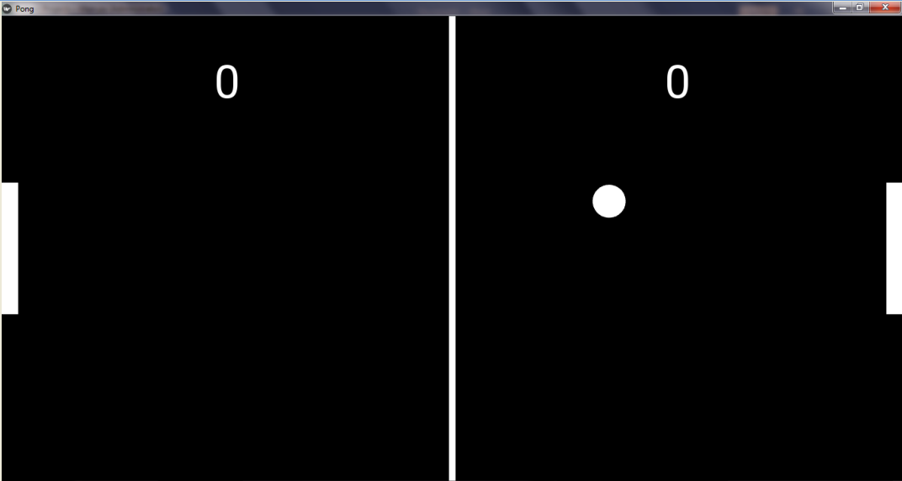

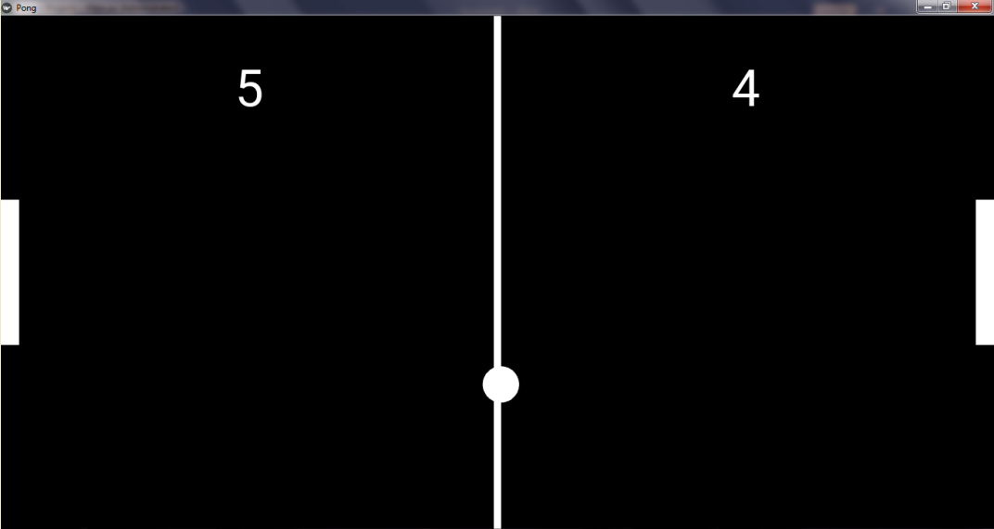

This is a Ping Pong Game created by me using Python and kivy. Ping Pong is a well-known casual game played by a lot of people so I also gave a try on this app. There is a white ball which keeps moving from one end to the other and the player has to hit the ball towards the other player using the white paddle provided. As seen in the second picture, the scores of the players also change automatically when the ball toucher either of the two side boundaries. And the best part of this game is that it is both android and desktop compatible. I have designed it in such a way that it recognizes mouse touch on the laptop as well as human touch on android which makes this app better. You can play along for as much as time you want and the scores will keep on updating. It also keeps records of the recent scores of games played.

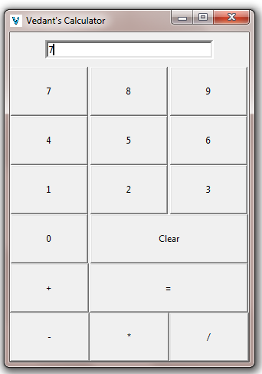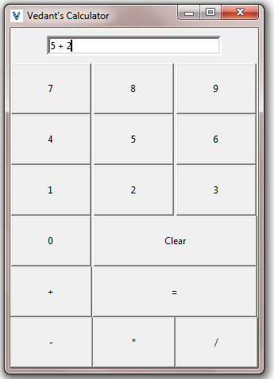2. **Simple Calculator:**

Calculator, as we all know is used for mathematical operations such as addition, multiplication, finding square roots, cube roots, etc. So here I have created a similar calculator using Python. It is a simple calculator which can perform simple operations such as addition, subtraction, multiplication and division. So, it is a handy tool when it comes to these simple operations. As you can see in the pictures, when we added 2 and 5 it gave us the result as 7. It cannot perform complex functions like square root, cube root, etc. but otherwise it works well.

* **Additional pics:**

